**UNDERSTANDING DATA STRUCTURES**

**NAME : SHUBHARTHAK SANGHARASHA**

**CLASS : AIML-4-C**

**UID : 20BCS6872**

# Write a program for array rotation

**PROGRAM CODE :-**

#include<iostream>

using namespace std;

int main()

{

int i,j,temp,a[5],n,k; // variable declarations

cout<<"Enter elements to rotate";

cin>>n; //taking number of rotation

cout<<"\nEnter elements:";

for(i=0;i<5;i++)

{

cin>>a[i]; //inputing elements inside the array

}

//algo

for(i=0;i<n;i++)

{ k=a[0];

for(j=0;j<5;j++)

{ temp=a[j];

a[j]=a[j+1];

a[j+1]=temp;

}

a[4]=k;

}

for(i=0;i<5;i++)

{

cout<<"\n"<<a[i];

}

return 0;

}

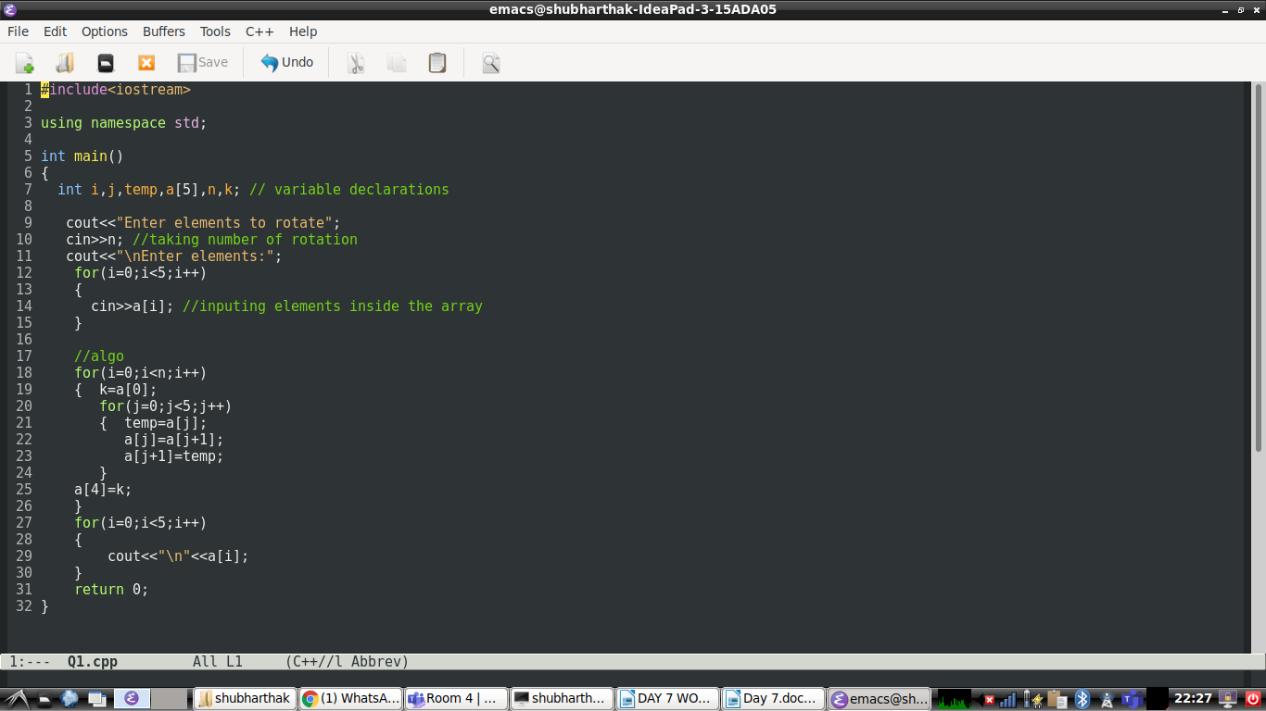

**Output:-**

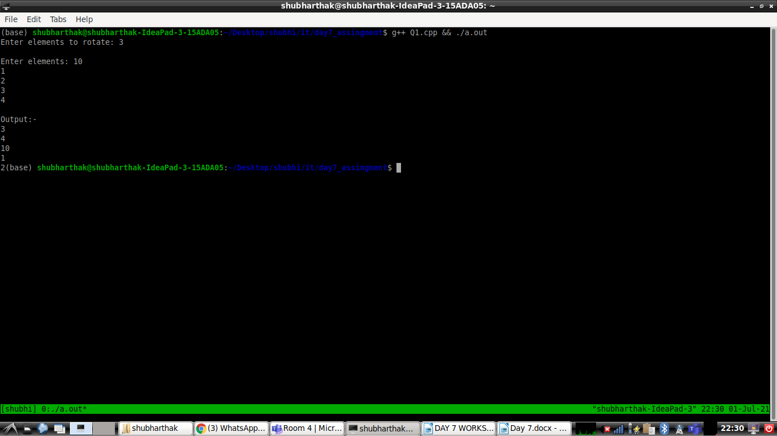

* Write a program to Rearrange an array such that arr[i] = i

**PROGRAM CODE:-**

#include<iostream>

using namespace std;

int main()

{ int i,j,temp,a[10];

cout<<"Enter elements";

for(i=0;i<5;i++)

{

cin>>a[i];

}

for(i=0;i<5;i++)

{ for(j=i+1;j<5;j++)

{

if(a[j]<a[i])

{ temp=a[i];

a[i]=a[j];

a[j]=temp;

}

}

}

cout<<"Array in arrange order\n";

for(i=0;i<5;i++)

{

cout<<a[i]<<"\n";

}

return 0;

}

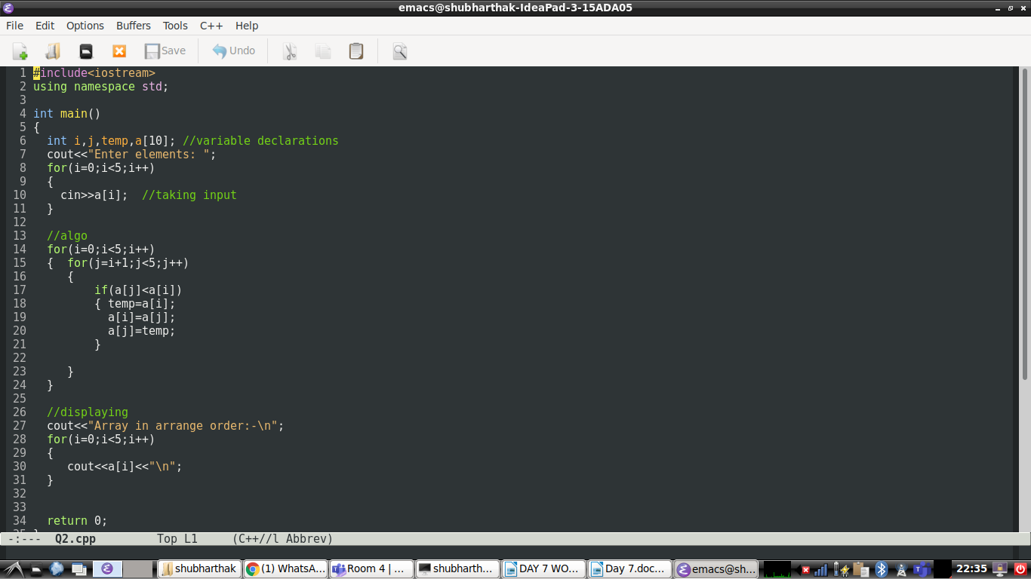

**OUTPUT:-**

